Using the scale bar macro

1. Finalize your graph so the x- and y-axis scales are appropriate for your figure.

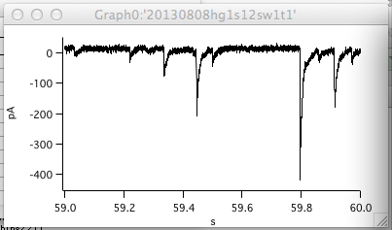

2. Select the “scalebar1” macro from the Macro menu list.

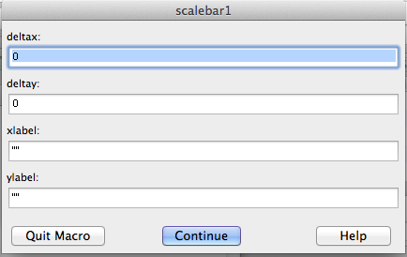

3. Enter the size of the x-axis scale bar in native units of the data (e.g. secs). In this case 0.1 for 0.1 sec.

4. Enter the size of the y-axis scale bar in native units (e.g. amps). In this case 100e-12 for 100 pA.

5. Enter the desired label for the x and y axes. You must match these with your actual scale sizes. In this case 100 msec and 100 pA. There is no error checking in this routine.

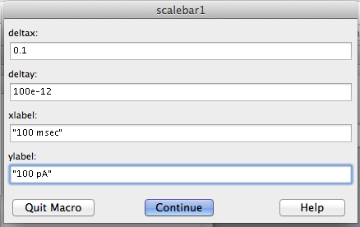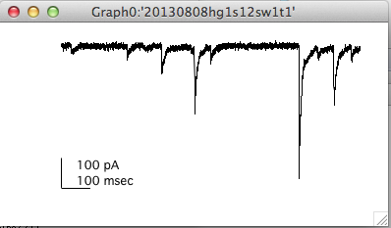

6. Double check your results!